Reagan Esteves, Jamie Hartman, Charles Tyndal, and Chenyu Zhao

CMPS-4010-01

Dr. Zheng

November 18, 2022

**Milestone 3: Skin Disease Diagnosis on Darker Skin Tones**

1. **Software Development**

The prototype code uses Python and was written in Google Colaboratory. Its purpose is to create a mask with RCNN for image segmentation. This code uses Pytorch to visualize as well as learn from other images to correctly identify the region of interest. In terms of layout, the code was divided into four blocks. The first block imported our google drive and imported libraries such as PIL, torch, and torchvision. PIL was used to enable Python for working on images, torch for tensors, and torchvision for image transformations in computer vision. The second block initializes the model using torchvision, set up the computation device (cuda), and uses transform to convert the image to tensor. The third block is for getting the bounding boxes and drawing the segmentation. Masks were assigned to each color channel (RGB) where a random colored mask was assigned to each object. All of the masks were combined into one image and the image was converted from PIL to NumPy format. Lastly, the fourth block runs the segmentation and bounding boxes through the images and the image result was displayed.

1. **Results from Software Development & Task Work**

The Buruli Ulcer (BU) images were run through the prototype segmentation code and the results of the bounding boxes were recorded on an excel sheet. The quality of the boxes was graded by three categories: bad, mid, and good. The results were categorized as bad if the bounding box did not get the body part (region of interest), mid if the bounding box had the body part and the background, and good if the bounding box was around the body part. Figure 1 shows a sample set of how the image results were categorized. The bad result had a boundary box on a feather in the upper left corner rather than on the foot. The mid result included the foot in the boundary box, but also included the background such as the bowl. The mid result could have been changed to a good if the boundary box was only on the foot. The good result had the boundary box focused only on the arm.

We ran 650 BU images where 34.5% were good, 33.2% were mid, 32.0% were bad, and 0.3% were no result (Fig 2). The no results were when there were no boundary boxes or highlights after running the image through the code. Based on the pie chart results, the success of the segmentation code was roughly ⅓ of the BU images. A correlation was detected for the bad results where most images had a busy background such as random objects rather than a uniform background. Thus, the prototype code was revised to improve segmentation results. Similarly, the Yaws (90 images total) were run through the prototype code where 24.1% were good, 64.4% were mid, and 21% were bad (Fig. 3). Three images were not counted for the rating as we were unable to determine what the region of interest was.

Because of the margin of error from the prototype code, we have been developing a new code to fix this issue. We will be testing another prototype code that uses VGG (Visual Geometry Group). The VGG code results will then be compared to the Mask RCNN code to determine if there is an increase in success on the accuracy of the mask on the body part.

1. **Meeting Plan & Accomplishments**

Our meeting schedule with Dr. Ding and Dr. Hamm is every two weeks. Our October meetings focused on the CITI training and our progress in it. In November, we were able to access the data set and our meetings consisted of going over the data set and the prototype code. Since milestone 2, each member completed 3 CITI training courses to access the skin disease dataset provided by Dr. Ding. The BU folder was split evenly among the members (~160 images each) to run through our prototype code. After running, members recorded the success of the segmentation on the images into the excel sheet to find possible correlations in segmentation failures.

1. **Timeline**

Since milestone 2, we have completed the CITI training and a prototype code for segmentation to obtain the region of interest. We are currently on par with our timeline and will revise our prototype code and run the VGG code for more efficient segmentation results by the first week of December (Fig. 4). Additionally, in late November, we will be comparing the RCNN code results to other neural networks like VGG. The task for contrast/lighting/angles will be done with the filtering/enhancement section. If we complete these tasks in time for the beginning of next semester, they will be utilized for AI identification and deep learning.

1. **Figures**

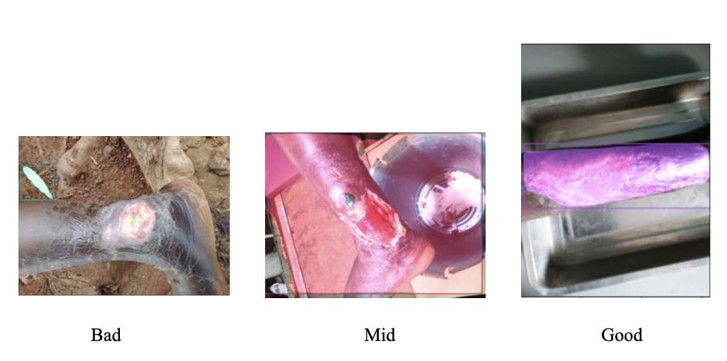

**Fig 1. Sample of Result Ratings**

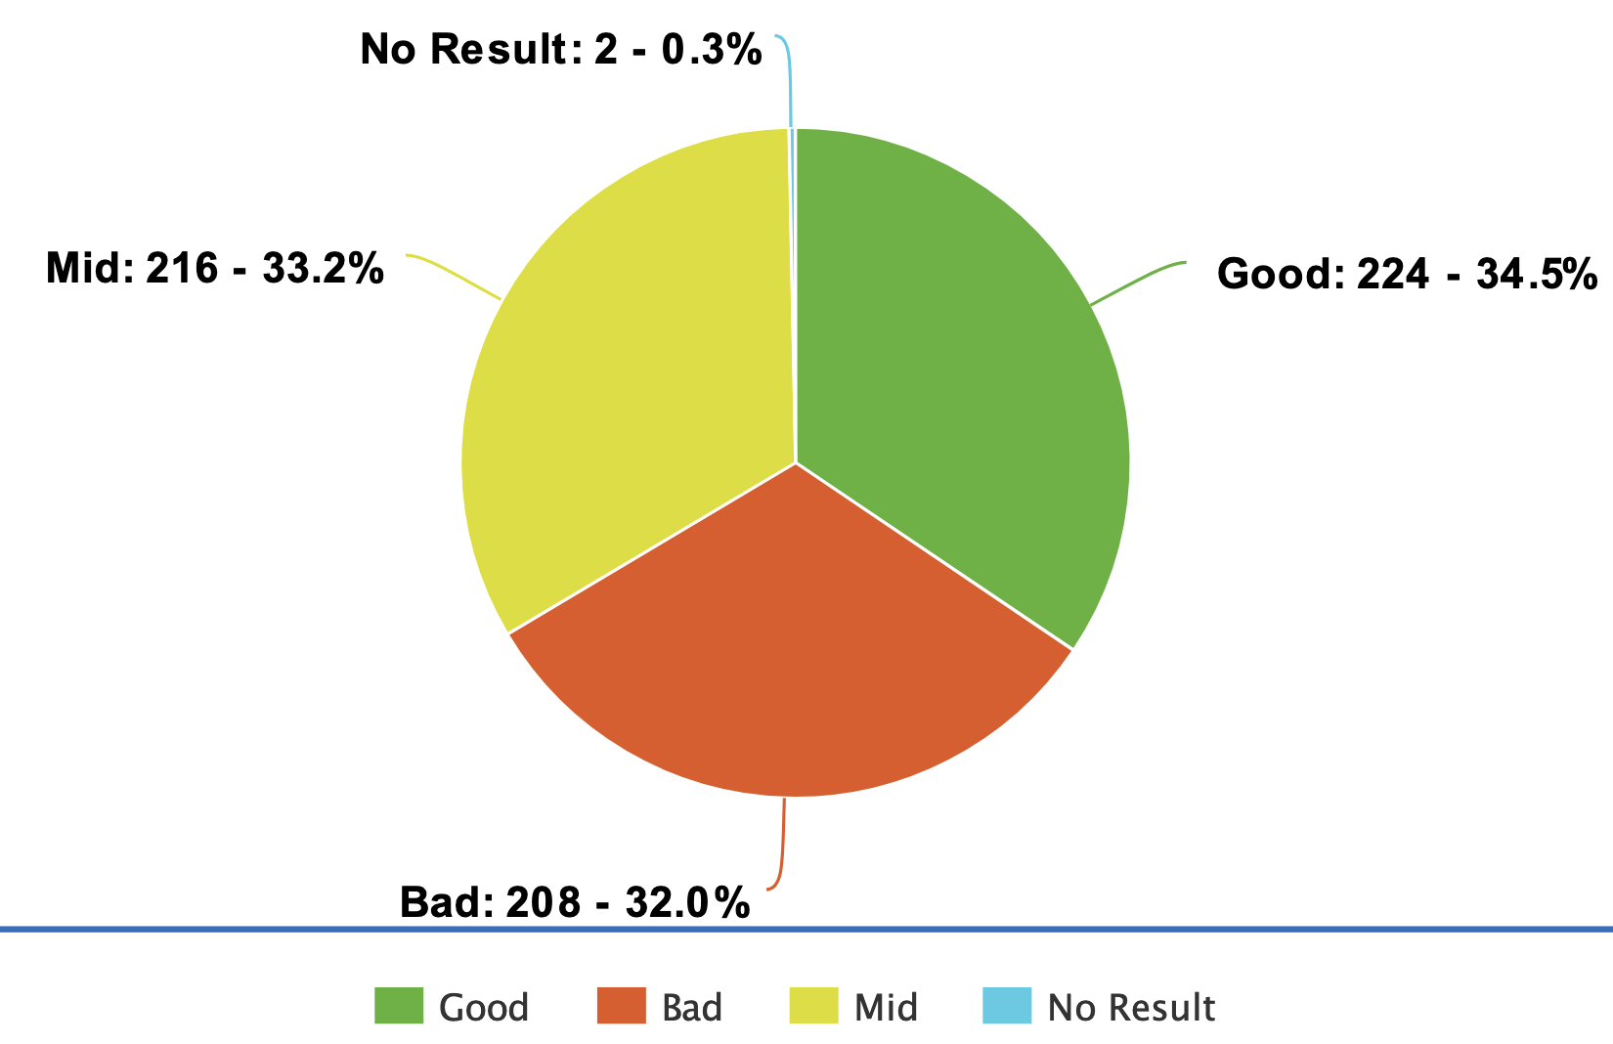

**Fig 2. Segmentation Result for Buruli Ulcer**

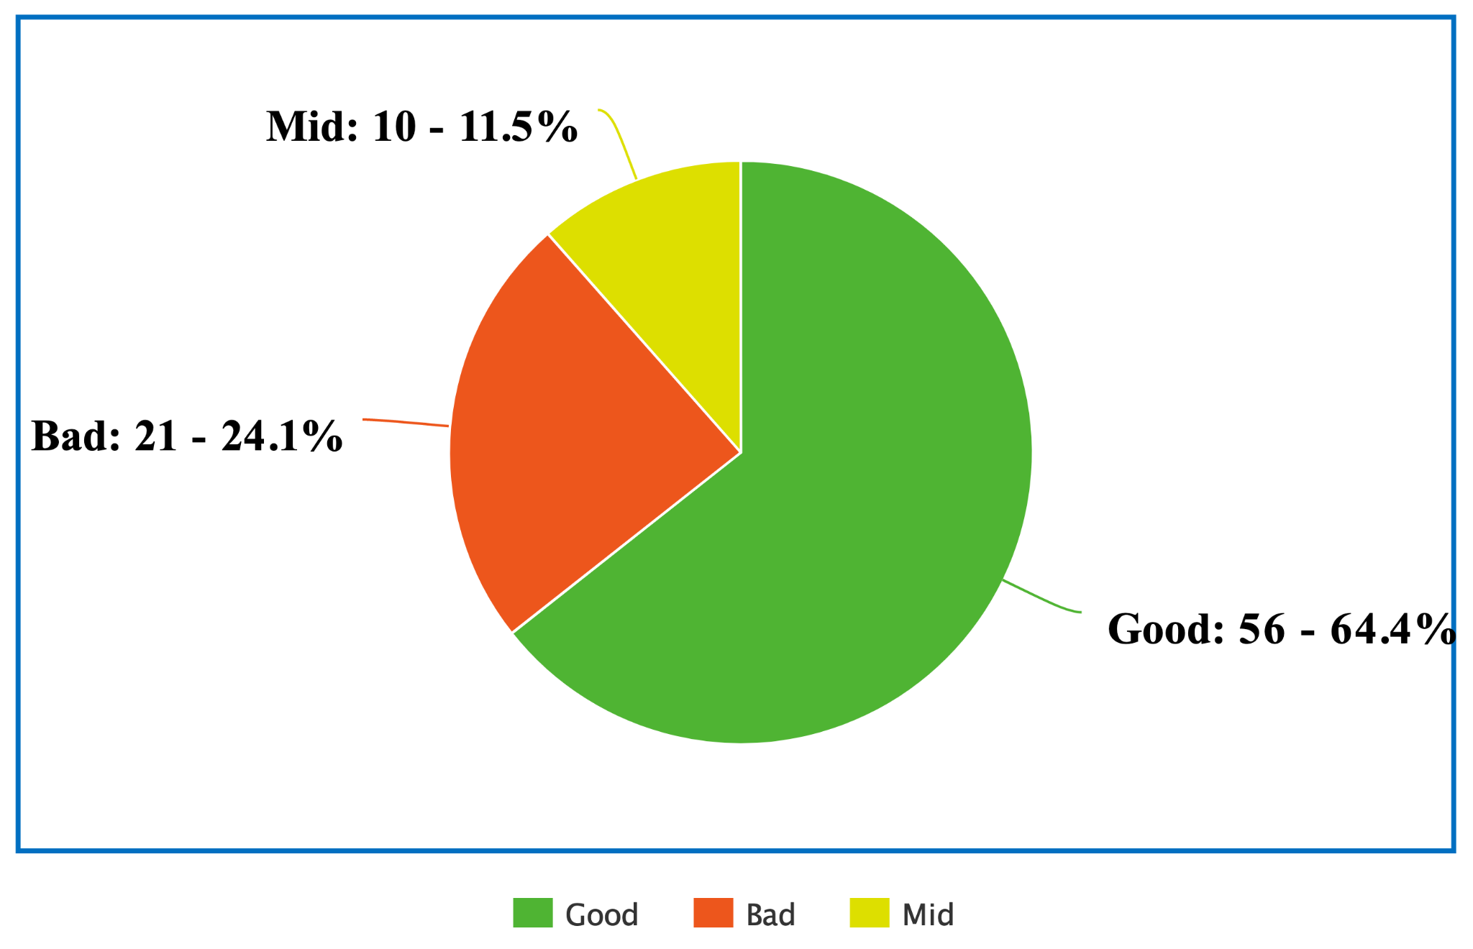

**Fig 3. Bounding Box Result for Yaws**

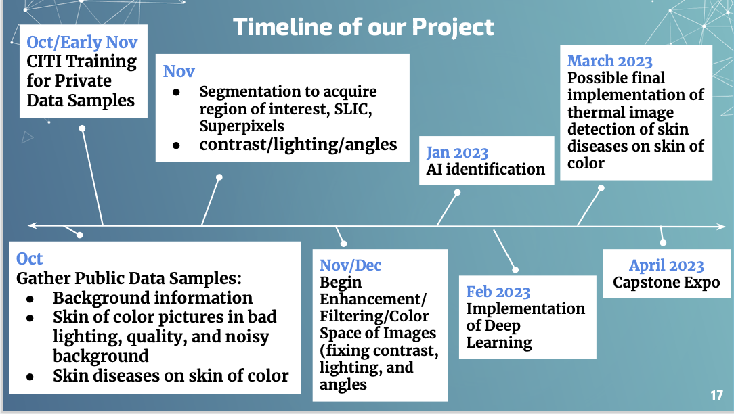

**Fig 4. Timeline of Capstone**